**GANPAT UNIVERSITY**

**U.V.PATEL COLLEGE OF ENGINEERING & TECHNOLOGY**

**Department of Computer Science and Engineering**

**B.Tech 1ST Semester**

**Subject – Essential of Software Foundation and Programming - I**

**First Name: Arshil      Enrollment Number: 14012111010         Stream : Mobile Applications**

**Assignment-1                                                                       Date: 27/8/2014**

**Requirements** – **C Compiler**

**Goal**-

**1. To learn the use of backslash characters.**

**2. To learn about characters and their ASCII values.**

**Deliverable :**

**1.       Source code with comments**

**2.      Outcomes / Output**

**1. Write a program to print ASCII values of all backslash characters and white space on screen in following format :**

**The ASCII value of ‘\t’ is : 9**

**(Hint : you can verify your ASCII values with the help of a table for ASCII values from text book)**

**Ans.**

**#include<stdio.h>**

**#include<conio.h>**

**void main()**

**{**

**clrscr();**

**printf("The ASCII value of \'\\t\' is : %d \n",'\t');**

**printf("The ASCII value of \'\\n\' is : %d \n",'\n');**

**printf("The ASCII value of \'\\a\' is : %d \n",'\a');**

**printf("The ASCII value of \'\\b\' is : %d \n",'\b');**

**printf("The ASCII value of \'\\f\' is : %d \n",'\f');**

**printf("The ASCII value of \'\\r\' is : %d \n",'\r');**

**printf("The ASCII value of \'\\v\' is : %d \n",'\v');**

**printf("The ASCII value of \'\\\\\' is : %d \n",'\\');**

**printf("The ASCII value of \'\\'\' is : %d \n",'\'');**

**printf("The ASCII value of \'\\\"\' is : %d \n",'\"');**

**printf("The ASCII value of \'\\?\' is : %d \n",'\?');**

**printf("The ASCII value of \' \' is : %d",' ');**

**getch();**

**}**

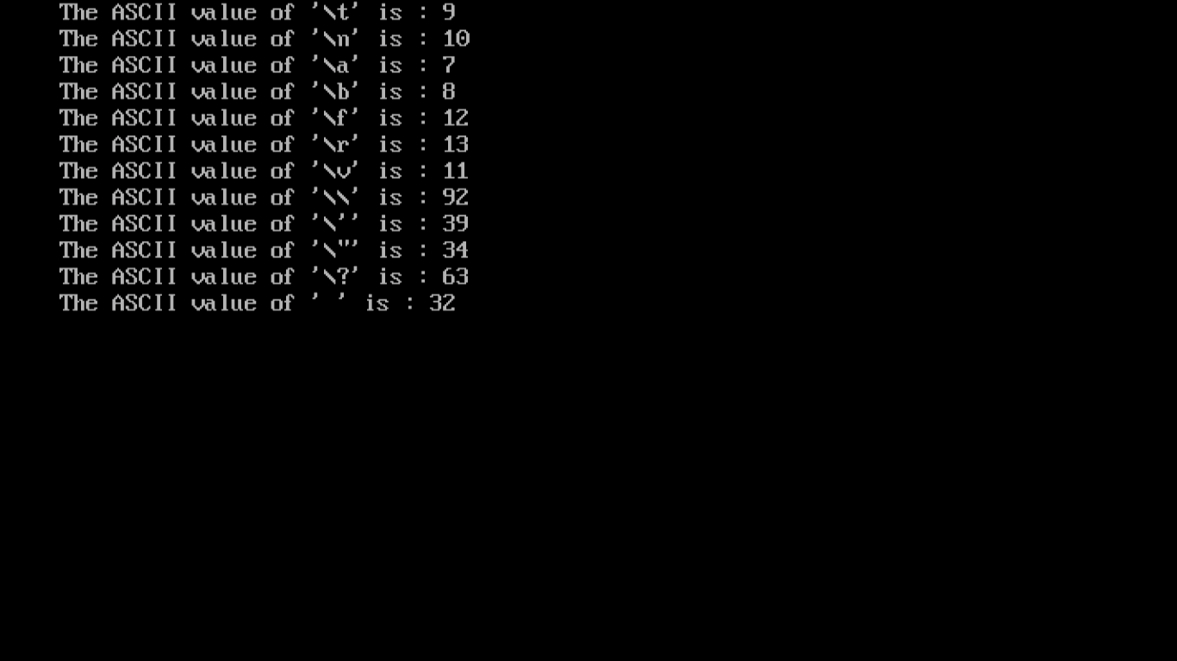

**2. Explain different data types available in C.**

**Ans. The basic data types in C include :**

1. **Int – It is used to store integers i.e. numbers without and decimal point. Its size is 2 bytes.**
2. **Char – Character data type is used to store characters (a-z, blank spaces etc). Its size is 1 byte.**
3. **Float – This data type is used to store floating point types (numbers with decimal**

**value). The size of float variables is 4 bytes.**

1. **Double – This data type is also used to store floating point types. The only difference is the size of double is 8 bytes and so has a bigger range than float.**

**Apart of the basic types there is void(no value) and derived data types such as arrays, structures and pointers.**

**3. Explain about C Tokens in brief.**

**Ans. The smallest individual units in C are called tokens. They are the basic building blocks of a C program. The tokens include:-**

1. **Keywords (eg: int, while),**
2. **Identifier (eg: main, total),**
3. **Constants (eg: 10, 20),**
4. **Strings (eg: “total”, “hello”),**
5. **Special symbols (eg: (), {}),**
6. **Operators (eg: +, /,-,*)**

**4. Explain about backslash characters in C.**

**Ans. In C programming after one, any number of spaces are ignored. So to do line breaks, put horizontal or vertical tabs backslash characters are used. Even though they seem like two characters they actually represent one character. These are non-printable and used to execute some special result in the output.**

**Eg - \n,\t etc.**